Experiment 4: Dilate an Image using Dilate Function
Software / Tools: Python · OpenCV (cv2) · NumPy

AIM
To read an image and apply the morphological Dilation operation to expand bright regions.
ALGORITHM
1. Import OpenCV and NumPy.
2. Read the input image.
3. Define a structuring element (kernel), e.g. a 5x5 matrix of ones.
4. Apply cv2.dilate() on the image using the kernel.
5. Display and save the dilated image.
PROGRAM (SOURCE CODE)
import cv2
import numpy as np

img = cv2.imread("image.jpg")
kernel = np.ones((5, 5), np.uint8)

# Apply Dilation
dilated_img = cv2.dilate(img, kernel, iterations=1)

cv2.imwrite("dilated_output.jpg", dilated_img)
cv2.imshow("Dilated Image", dilated_img)
cv2.waitKey(0)
cv2.destroyAllWindows()

OUTPUT
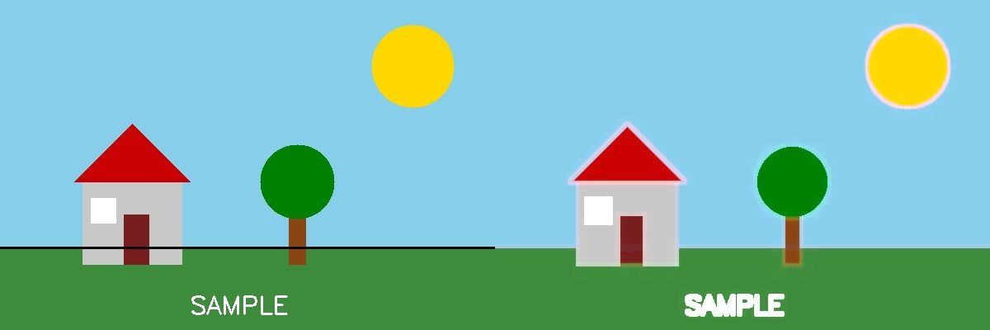
Fig. 4 — Output of Experiment 4: Dilate an Image using Dilate Function.
RESULT
Read an image and apply the morphological Dilation operation to expand bright regions — completed successfully, as demonstrated in the output shown above.

